Father R. Perin School Newsletter, October 2023
Edlánat’e
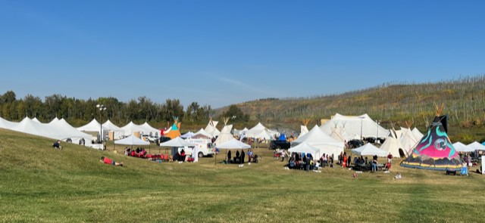
On September 14 and 15, Father R. Perin School students attended the ATC Cultural Festival in Fort McMurray. It was great to see our youth enjoying and participating in the many workshops and cultural events/ activities.
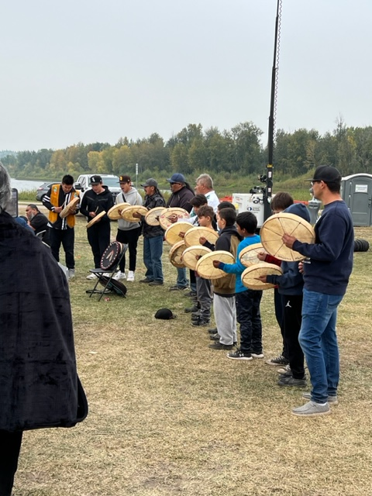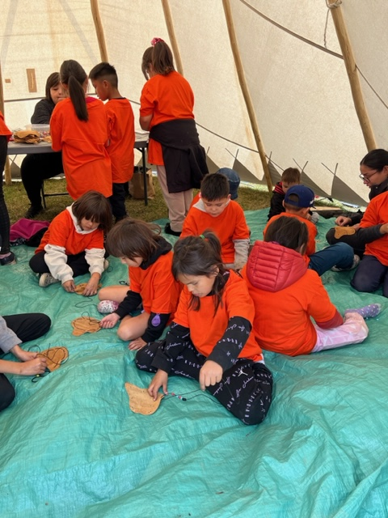
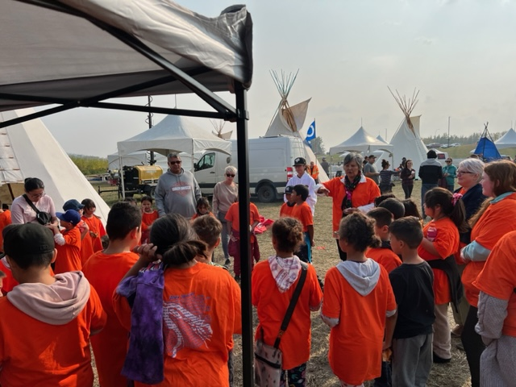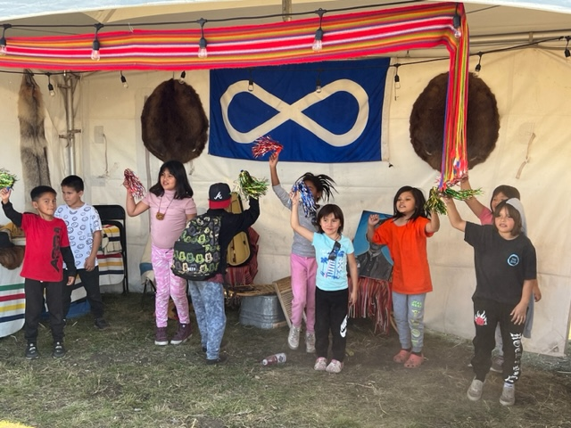
On September 19, Grades 6-9 students participated in and very much enjoyed a careers workshop field trip in Fort McMurray. The trip was sponsored by the Indigenous Youth Learning Circle.
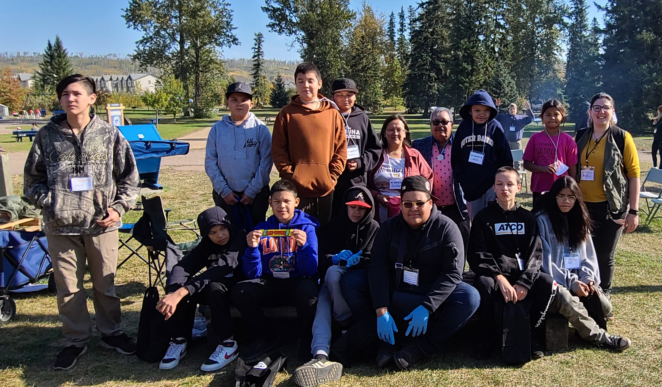
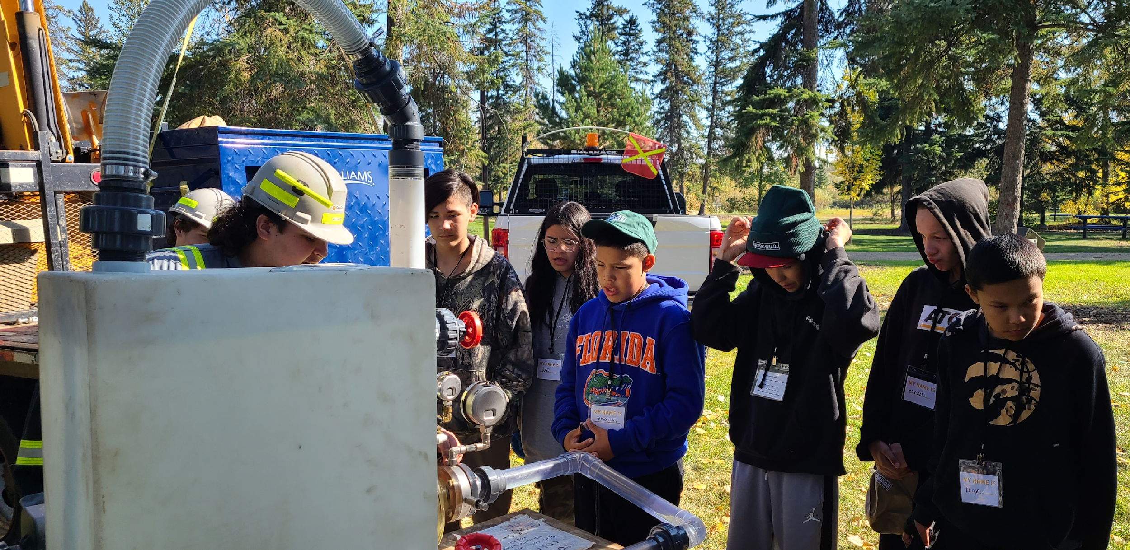
Here are some important September dates since our last Newsletter:
- September 25- 28, Father R. Perin School students participated in various learning activities provided by the National Centre for Truth and Reconciliation. The website can be reached by this link: https://nctr.ca/.
- September 27, Father R. Perin School conducted a fire drill emergency practice procedure, all students evacuated the building in an orderly and timely manner and gathered with their class in the designated muster point. Great job students! We will conduct ongoing emergency procedure practices throughout the year. Student safety is a top priority.
- September 27 & 28, Father R. Perin School students participated in the Community Wellness Workshop at the Janvier Multiplex. It was great to see many of our youth participating and especially being positive role models and drumming in the opening ceremony.

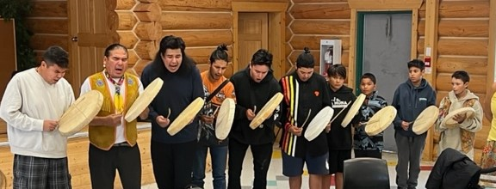
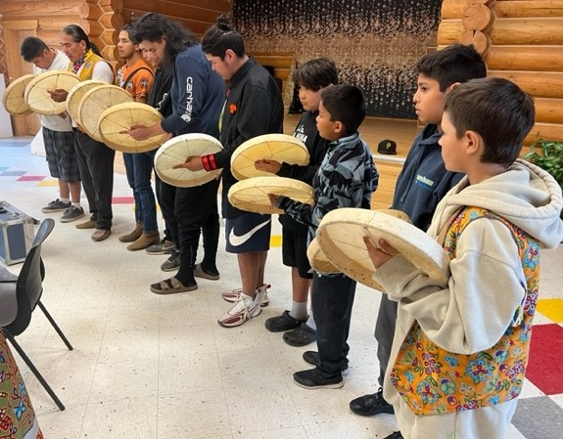
- September 28, Orange Shirt Day at Father R. Perin School.
- September 29, Professional Learning Day for all staff, no school for students.
- September 30, National Day for Truth and Reconciliation.

Here are some important and upcoming October dates:

- October 5, Science in Motion visit from Telus World of Science, all students will have the opportunity to visit the mobile planetarium and participate in science sessions titled Aurora Borealis (Northern Lights) and Legends of the Sky (from an Indigenous perspective).
- October 9, Thanksgiving Day holiday, no school.
- October 10, Father R. Perin School will be hosting a community Thanksgiving dinner at noon, everyone is invited and we hope to see you there.
- October 11, Wood Buffalo Regional Library visit to Grades K-9 students, enrichment programming for all students.
- October 17, Skateboarding presentation at Janvier Skatepark for all students and Bbq sponsored by RMWB.
- October 18, Earth Rangers presentation for Grades K-9, enrichment programming for all students.
- October 19, Swimming field trip in Fort McMurray, Grades 4-9.
- October 20, Fire Prevention presentation for Grades K-3.
- October 24, Swimming field trip in Fort McMurray, Grades K-3.
- October 26, Father R. Perin School will continue from last year in sending home monthly literacy packages, please watch for them on this day.
- October 31, Fun Day Halloween activities at Father R. Perin School sponsored by RMWB; pancake breakfast, spaghetti and garlic toast lunch, and fun activities. Parents/ guardians and elders are invited and we hope to see you there.

On the first day back to school on Tuesday, September 5, Father R. Perin School held a draw for an iPad courtesy of ATC. The names of all students present on that day were put into a draw. Congratulations to our winner Sophia Herman!

On September 21, Father R. Perin School hosted a community gathering/ welcome back to school Bbq. This was a great opportunity for school staff to connect with parents/ guardians and community members , marsi cho for attending. There will be ongoing community events hosted by the school throughout the year and parents/ guardians and community members are always very welcome.
Strategic areas of focus at Father. R. Perin School will be:
- Excellence in Learning
- Excellence in Leadership
- Excellence in Relationships.
All students receive instruction in Dene and land based cultural learning. Recently, the Grades K-9 students attended ATC’s Cultural Festival in Fort McMurray. Also, the Grades 6-9 students attended a careers workshop hosted by the Indigenous Youth Learning Circle in Fort McMurray. Students from Grades K-9 also participated in a community wellness workshop at the multiplex.
Father R. Perin School will continue to send home monthly literacy packages. These packages are not meant to be returned. They will consist of various literacy materials in which students can work on with family members. The objective is to provide families with extra educational materials in order to further reinforce teachings at home. Literacy and numeracy are a Northland School Division focus and teachers will receive ongoing professional development training in those areas throughout the year. All students will have daily access to lexia and symphony online literacy and numeracy learning supports which are meant to enhance classroom instruction. In addition, some parents/ guardians have signed up their children for extra literacy home support through Chapter One (if you wish to sign up your child for extra support, please contact the school). Father R. Perin School will be using a program called Math Minds that utilizes JUMP Math as a resource whereby students progress at their own pace according to their respective levels.
It is very important for students to be on time and attend school each day and to participate in the daily learning activities. Father R. Perin School recognizes students with good attendance through a monthly rewards and recognition program. If your child is unable to be at school on any particular day, please notify the school.
One of our most important teachings centers around respect and responsibility. Learning to take responsibility for one’s own actions and learning respect will have many lifelong benefits. In school, students learn about cultural values of respecting themselves, respecting others, respecting property, and respecting the environment.
Open communication is encouraged and Father R. Perin School welcomes and values your opinion and suggestions. Please remember if you have a concern, reach out to your child’s teacher or contact the school.
Father R. Perin School will soon be having our first school council meeting of the school year and our new school council will be established. It will be great to see parents/ guardians attend. Once finalized, the date will be announced.
There have been a few incidents of head lice at Father R. Perin School. Please remember to check your child for head lice on a regular basis. If your child has head lice, treatment is available through the health centre.
Father R. Perin School promotes healthy lifestyles. Students should not be coming to school with unhealthy foods containing high amounts of processed sugar and/ or caffeine. Students should not be bringing pop, energy drinks, candy, or gum to school.
Please remember for safety reasons, it is very important that students have a pair of indoor shoes.
Father R. Perin will soon be hosting after school activities on Tuesdays and Thursdays (details will be forthcoming).
A very big thank you is extended to parents/ guardians for your ongoing support, marsi cho!

